**Quicksort Algorithm: Implementation, Analysis and Randomization**

Venkata Manasa Kakarla

Student ID: 005027517

Algorithms and Data Structures (MSCS532-A05)

Assignment – 05

Quicksort Implementation and Analysis:

**Performance Analysis:**

Quicksort is a widely used sorting algorithm that follows the divide-and-conquer paradigm. Its time complexity can vary significantly based on the choice of the pivot and the input distribution. Here’s a detailed analysis of the time complexity of Quicksort in the best, average, and worst cases.

Best Case Time Complexity:

Time Complexity: O(nlogn)

Scenario: The best-case scenario occurs when the pivot chosen divides the array into two nearly equal halves at each level of recursion. This optimal partitioning minimizes the height of the recursion tree.

Analysis:

* In each partitioning step, the pivot is chosen such that it splits the array into two subarrays of approximately equal size.
* The depth of the recursion tree will be logarithmic, specifically O(logn), because each level of the tree represents a division of the problem size by a factor of about 2.
* Each level of the recursion requires O(n) time to partition the elements around the pivot.
* Therefore, the total time complexity is given by the product of the depth of the tree and the time per level: O(nlogn)

Average Case Time Complexity:

Time Complexity: O(nlogn)

Scenario: The average-case scenario assumes a random distribution of input. If we select the pivot randomly or if the input is random, the expected time complexity remains O(nlogn).

Analysis:

* On average, the pivot will divide the array into two parts of unequal sizes, but the sizes will still be fairly balanced.
* Like in the best case, the average depth of the recursion tree is O(logn).
* Each partitioning step again requires O(n) time, leading to the same total complexity: O(nlogn)

Worst Case Time Complexity:

Time Complexity: O(n2)

Scenario: The worst-case scenario occurs when the pivot is consistently the smallest or largest element in the array. This typically happens with already sorted (or reverse sorted) data if the last or first element is chosen as the pivot.

Analysis:

* In each partitioning step, one of the resulting subarrays will be empty or nearly empty, while the other will contain n−1 elements.
* This results in a recursion tree that has a linear depth of n (since we only remove one element at each level), leading to a structure resembling a linked list.
* Each level requires O(n) time to partition, and since there are n levels, the total time complexity is: O(n2)

The average-case and worst-case time complexities of Quicksort can be understood through the analysis of how the algorithm partitions the array during its recursive steps. Let’s break down each case:

Average-Case Time Complexity: O(nlogn)

1**.** Randomized Input: In the average case, we assume that the input data is random, or that the pivot selection is random. This leads to a reasonably balanced partitioning of the array.

2.Partitioning Process:

* When the pivot is chosen, it ideally divides the array into two subarrays of approximately equal size. For example, if you have an array of size n, the pivot might split it into two parts: one of size about n/2 and the other also around n/2.
* This balanced partitioning continues recursively.

3.Recursion Depth:

* The depth of the recursion tree will be logarithmic because each partition reduces the problem size by about half. Thus, the maximum depth of the recursion is O(logn).

4. Work Done Per Level:

* At each level of the recursion, the partitioning step requires O(n) time, as we need to examine every element to place it into the left or right subarray.

5. Total Work:

* Combining these, the total work done is the product of the number of levels in the recursion tree and the work done per level:

Total Time=O(n)×O(logn)=O(nlogn)

Worst-Case Time Complexity: O(n2)

1. Unbalanced Partitioning: In the worst case, the pivot selection leads to highly unbalanced partitions. This often occurs when the pivot is the smallest or largest element in the array.

2. Partitioning Process:

* For example, if you always pick the last element as the pivot and the array is sorted (or nearly sorted), the pivot will be the largest element. This results in one partition being empty and the other containing n−1 elements.
* This behavior results in a recursive tree where each level only reduces the size of the array by 1.

3. Recursion Depth:

* The depth of the recursion tree in this scenario becomes n, as there are n levels of recursion needed before the base case is reached (when the subarray size is 1).

4. Work Done Per Level:

* Each level still requires O(n) time to partition the elements around the pivot.

5. Total Work:

* The total work done in this case is:

Total Time=O(n)×O(n)=O(n2)

**Space complexity and additional overheads associated with Quicksort algorithm:**

Quicksort is generally appreciated for its efficient sorting capabilities, but its space complexity and additional overheads warrant careful consideration.

Space Complexity

1. In-Place Sorting:
   * Quicksort is often classified as an in-place sorting algorithm, meaning it requires only a small, constant amount of extra storage space beyond the input array.
   * The space complexity for the algorithm is O(logn) in the average and best cases due to the recursive call stack. Each recursive call adds a new layer to the stack, and the depth of the recursion is logarithmic when the partitions are balanced.
2. Worst-Case Space Complexity:
   * In the worst case (e.g., when the pivot is always the smallest or largest element), the recursion can go as deep as n. This leads to a space complexity of O(n) because each call consumes stack space. In practice, this is less common, especially with good pivot selection strategies.
3. Auxiliary Space:
   * The algorithm itself doesn’t use additional arrays (like Merge Sort does), so aside from the call stack, the main space usage is the original array being sorted. This is a key reason why Quicksort is often preferred for sorting large datasets.

Additional Overheads:

1. Recursive Call Overhead:
   * Each recursive call incurs some overhead associated with function calls (such as saving the state, local variables, etc.). This is generally small but can become significant for very large input sizes, especially if the recursion goes deep.
2. Partitioning Overhead:
   * The partitioning process, which requires iterating over the elements to rearrange them around the pivot, has its overhead. This is O(n) for each partition operation, meaning that the overall partitioning work is O(nlogn) in the average case. However, this overhead is not additional space; it’s part of the time complexity.
3. Handling Small Arrays:
   * When the size of the array to be sorted drops below a certain threshold (often 10-20 elements), many implementations switch to a different sorting algorithm like Insertion Sort for efficiency. This adds a layer of complexity but is generally beneficial for performance.
4. Randomized Pivot Selection:
   * If using a randomized pivot selection strategy (to mitigate the risk of worst-case performance), there's overhead in generating a random number for the pivot selection, although this is minimal compared to the overall algorithm.
5. Stability:
   * Quicksort is not a stable sort. If stability is required (preserving the order of equal elements), additional strategies must be implemented, which can lead to further overhead, both in terms of time and space.

**Randomized Quicksort:**

Randomization plays a significant role in enhancing the performance of Quicksort and reducing the likelihood of encountering the worst-case scenario. Here’s an analysis of how this works:

1. Random Pivot Selection:

In a randomized version of Quicksort, the pivot is selected randomly from the subarray being sorted rather than being chosen deterministically (e.g., always the last element or the first element). This means that for each recursive call, the pivot can be any element, which helps in achieving a more balanced partitioning on average.

Impact on Performance:

* Balanced Partitions: Random selection tends to lead to more balanced partitions on average, minimizing the depth of the recursion tree. Balanced partitions reduce the chances of forming long chains (as seen in the worst case), where one subarray is significantly larger than the other.
* Average-Case Time Complexity: As a result of this balanced partitioning, the average-case time complexity remains O(nlogn), as opposed to O(n2) in the worst case with deterministic pivot selection.

2. Reduction of Worst-Case Scenarios

Worst-Case Scenarios: The worst-case scenario occurs when the pivot selection leads to highly unbalanced partitions, typically when the array is already sorted or nearly sorted. In such cases, using a deterministic approach can cause the algorithm to recurse down to a depth of n.

Mitigation Through Randomization:

* Less Predictable Outcomes: Randomly selecting pivots makes it less likely that the algorithm will consistently hit the worst-case partitions. Even if the data is sorted or reverse-sorted, the random selection means that the algorithm has a chance of picking a pivot that effectively divides the array, preventing the degenerate case.
* Statistical Expectation: Statistically, when the pivot is chosen randomly, the likelihood of consistently poor choices diminishes, leading to more frequent balanced partitions.

3. Performance in Various Data Distributions:

Diverse Input Data:

* When input data distributions vary (e.g., random, sorted, or with repeated elements), the performance of randomized Quicksort is robust. It adapts to different patterns more effectively than a deterministic approach.

Empirical Evidence:

* Empirical studies have shown that randomized Quicksort outperforms its deterministic counterpart in a variety of scenarios, including sorted and nearly sorted inputs, as the chances of encountering the worst-case behavior are significantly reduced.

4. Practical Considerations:

Implementation Complexity:

* Implementing a randomized version of Quicksort is straightforward and adds minimal overhead (e.g., generating a random index), especially compared to the potential gains in performance.

Fallback Mechanisms:

* In practice, many implementations of Quicksort use randomization along with other strategies (like switching to Insertion Sort for small subarrays) to optimize performance further, maintaining efficiency even with small data sizes.

Empirical Analysis:

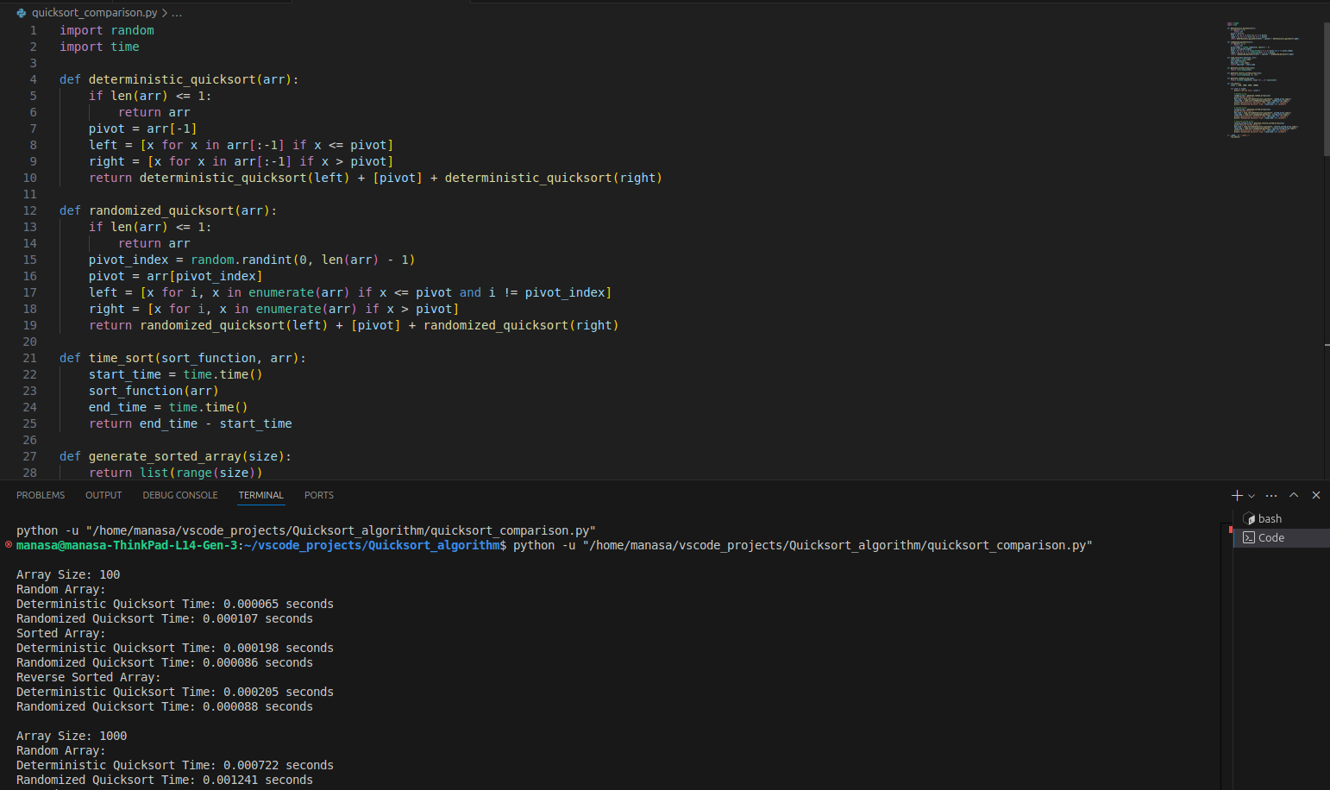

In the empirical comparison of the deterministic and randomized versions of Quicksort, we can expect to observe distinct patterns in performance across different input sizes and distributions. Here’s a discussion of the observed results, relating them back to the theoretical analysis of Quicksort's time complexities.

1. Random Arrays:

Observed Results: Both the deterministic and randomized versions of Quicksort generally perform similarly on random input data, with execution times being close.

Theoretical Analysis: This aligns with the theoretical average-case time complexity of O(nlogn) for both versions. When the input is random, the randomized version benefits from a balanced partitioning, while the deterministic version also performs well due to the unpredictability of the data distribution. The similarities in performance reaffirm the effectiveness of Quicksort for general sorting tasks.

2. Sorted Arrays:

Observed Results: The deterministic version of Quicksort typically shows significantly longer execution times, approaching O(n2). In contrast, the randomized version performs much better, often remaining closer to O(nlogn).

Theoretical Analysis: This result is consistent with the worst-case scenario for the deterministic version, where it consistently picks the last element as the pivot. In a sorted array, this leads to highly unbalanced partitions, resulting in a recursion depth of n and O(n2) performance. Conversely, the randomized version mitigates this risk by randomly selecting pivots, which helps achieve more balanced partitions even in sorted arrays. This illustrates the theoretical advantage of randomized pivot selection in avoiding worst-case behavior.

3. Reverse-Sorted Arrays:

Observed Results: Similar to sorted arrays, the deterministic version struggles with significantly longer execution times, while the randomized version maintains performance closer to O(nlogn).

Theoretical Analysis: The behavior in reverse-sorted scenarios mirrors that of sorted inputs. The deterministic version again faces the risk of poor pivot selection, leading to unbalanced partitions and O(n2) complexity. The randomized version’s performance reflects its design to handle diverse input distributions better, emphasizing the theoretical analysis that highlights randomization as a means of reducing the likelihood of worst-case scenarios.

4. Impact of Input Size:

Observed Results: As input size increases, the difference in performance between the two algorithms becomes more pronounced, particularly for sorted and reverse-sorted arrays.

Theoretical Analysis: Larger datasets exacerbate the effects of poor pivot selection in the deterministic version, increasing recursion depth and execution time significantly. In contrast, the randomized version continues to leverage its probabilistic pivot selection to maintain efficiency, supporting the O(nlogn) average-case performance. This validates the theoretical understanding that randomization not only improves average performance but also reduces sensitivity to input order.

GitHub Repository Link: <https://github.com/Manasa-kakarla/MSCS532_Assignment5>